Name: Jadhav Somnath Pandurang

Class: BCA – III Sem – V

Roll No: 86

**LAB EXERCISE 1**

**Ques . Write a program to display even no and odd no using C#.**

**Code:**

using System;

using System.Collections.Generic;

using System.Linq;

using System.Text;

using System.Threading.Tasks;

namespace OddEvenNumber

{

class Program

{

static void Main(string[] args)

{

int num = int.Parse(args[0]);

if (num % 2 == 0)

{

Console.Write("Given Number is Even");

}

else

{

Console.Write("Given Number is Odd");

}

Console.Read();

}

}

}

**Output:**

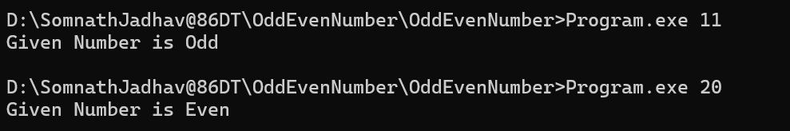

Name: Jadhav Somnath Pandurang

Class: BCA – III Sem – V

Roll No: 86

**LAB EXERCISE 2**

**Ques . Write a program to demonstrate parameter passing mechanism and out parameter.**

**Code:**

using System;

using System.Collections.Generic;

using System.Linq;

using System.Text;

using System.Threading.Tasks;

namespace ParameterPassing

{

class Program

{

void SwapByValue(int x, int y)

{

int temp = x;

x = y;

y = temp;

}

void SwapByReference(ref int x, ref int y)

{

int temp = x;

x = y;

y = temp;

}

void AreaOfRectangle(out int length, out int width, out int area)

{

length = 10;

width = 5;

area = length * width;

}

static void Main(string[] args)

{

Program obj = new Program();

int a = 10, b = 20;

Console.WriteLine("Before Swapping: A = " + a + " B = " + b);

obj.SwapByValue(a, b);

Console.WriteLine("\n--- Using Pass By Value ---");

Console.WriteLine("After Swapping: A = " + a + " B = " + b);

obj.SwapByReference(ref a, ref b);

Console.WriteLine("\n--- Using Pass By Reference ---");

Console.WriteLine("After Swapping: A = " + a + " B = " + b);

int len, wid, area;

obj.AreaOfRectangle(out len, out wid, out area);

Console.WriteLine("\n--- Using Out Parameters ---");

Console.WriteLine("Length = " + len + " Width = " + wid + " Area = " + area);

Console.ReadLine();

}

}

}

**Output:**

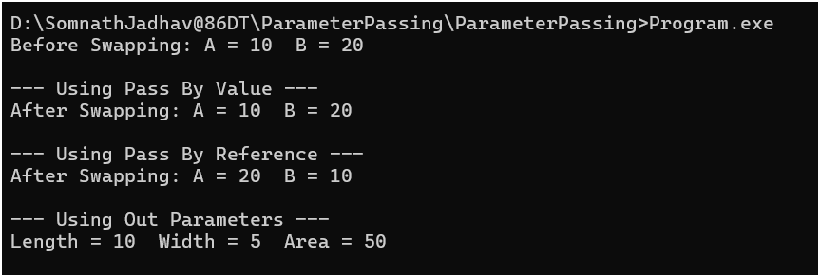

Name: Jadhav Somnath Pandurang

Class: BCA – III Sem – V

Roll No: 86

**LAB EXERCISE 3**

**Ques . Write a program to demonstrate type casting.**

**Code:**

using System;

using System.Collections.Generic;

using System.Linq;

using System.Text;

using System.Threading.Tasks;

namespace TypeCasting

{

class Program

{

static void Main(string[] args)

{

int num1 = 100;

double num2 = num1;

Console.WriteLine("Type Casting Demonstration** \n");

Console.WriteLine("Implicit Casting");

Console.WriteLine("Integer value : " + num1);

Console.WriteLine(" int --> double: " + num2);

Console.WriteLine();

double num3 = 320.98;

int num4 = (int)num3;

Console.WriteLine("Explicit Casting");

Console.WriteLine("Double value : " + num3);

Console.WriteLine("double --> int: " + num4);

Console.WriteLine();

string str = "1234";

int str1 = int.Parse(str);

Console.WriteLine("String value : " + str);

Console.WriteLine("String to Integer : " + str1);

Console.Read();

}

}

}

**Output:**

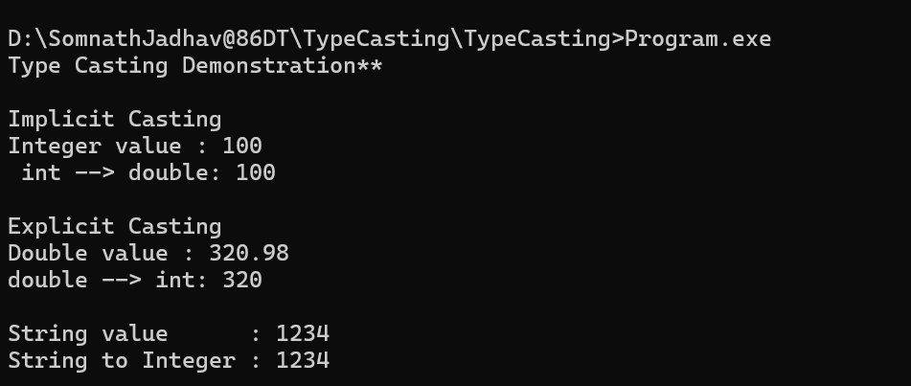

Name: Jadhav Somnath Pandurang

Class: BCA – III Sem – V

Roll No: 86

**LAB EXERCISE 4**

**Ques . Write a program to demonstrate partial class.**

**Code:**

using System;

using System.Collections.Generic;

using System.Linq;

using System.Text;

using System.Threading.Tasks;

namespace PartialClassDemonstration

{

partial class Student

{

int id;

string name;

public void setData(int id, string name)

{

this.id = id;

this.name = name;

}

}

partial class Student

{

int age;

public Student()

{

age = 10;

}

public void display()

{

Console.WriteLine("Id : " + id + "\nName : " + name + "\nAge : " + age);

}

}

class Program

{

static void Main(string[] args)

{

Console.WriteLine("**Partial Class Demonstration**\n");

Student s1 = new Student();

s1.setData(86, "Somnath Jadhav");

s1.display();

Console.Read();

}

}

}

**Output:**

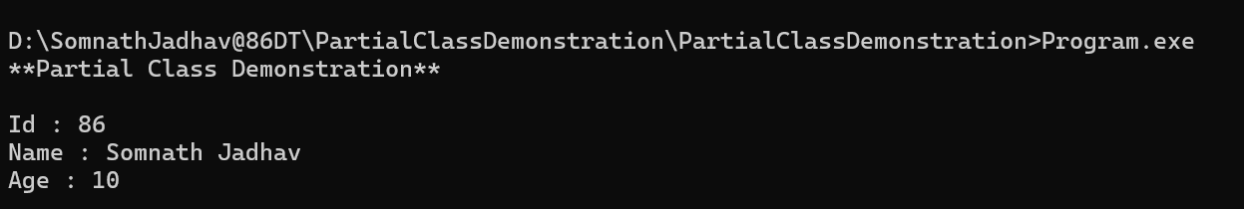

Name: Jadhav Somnath Pandurang

Class: BCA – III Sem – V

Roll No: 86

**LAB EXERCISE 5**

**Ques . Create web page using server controls- Textbox, List Controls, Calender, Imagebutton, Linkbutton**

**Code:**

using System;

using System.Collections.Generic;

using System.Linq;

using System.Web;

using System.Web.UI;

using System.Web.UI.WebControls;

public partial class _Default : System.Web.UI.Page

{

protected void Page_Load(object sender, EventArgs e)

{

}

protected void CheckBoxList1_SelectedIndexChanged(object sender, EventArgs e)

{

Label3.Text = "You selected: ";

foreach (ListItem li in CheckBoxList1.Items)

{

if (li.Selected)

{

Label3.Text += " " + li;

}

}

}

protected void DropDownList1_SelectedIndexChanged(object sender, EventArgs e)

{

Label4.Text = "You selected: " + DropDownList1.SelectedItem.Text;

}

protected void ListBox1_SelectedIndexChanged(object sender, EventArgs e)

{

Label5.Text = "You selected: " + ListBox1.SelectedItem.Text;

}

protected void RadioButtonList1_SelectedIndexChanged(object sender, EventArgs e)

{

Label6.Text = "You selected: " + RadioButtonList1.SelectedItem.Text;

}

protected void LinkButton1_Click(object sender, EventArgs e)

{

}

protected void TextBox1_TextChanged(object sender, EventArgs e)

{

}

protected void TextBox1_TextChanged1(object sender, EventArgs e)

{

Label13.Text = "You Entered : ";

Label13.Text += TextBox1.Text;

}

protected void Calendar1_SelectionChanged(object sender, EventArgs e)

{

Label14.Text = "Selected Date : ";

Label14.Text += Calendar1.SelectedDate.ToLongDateString();

}

}

**Output:**

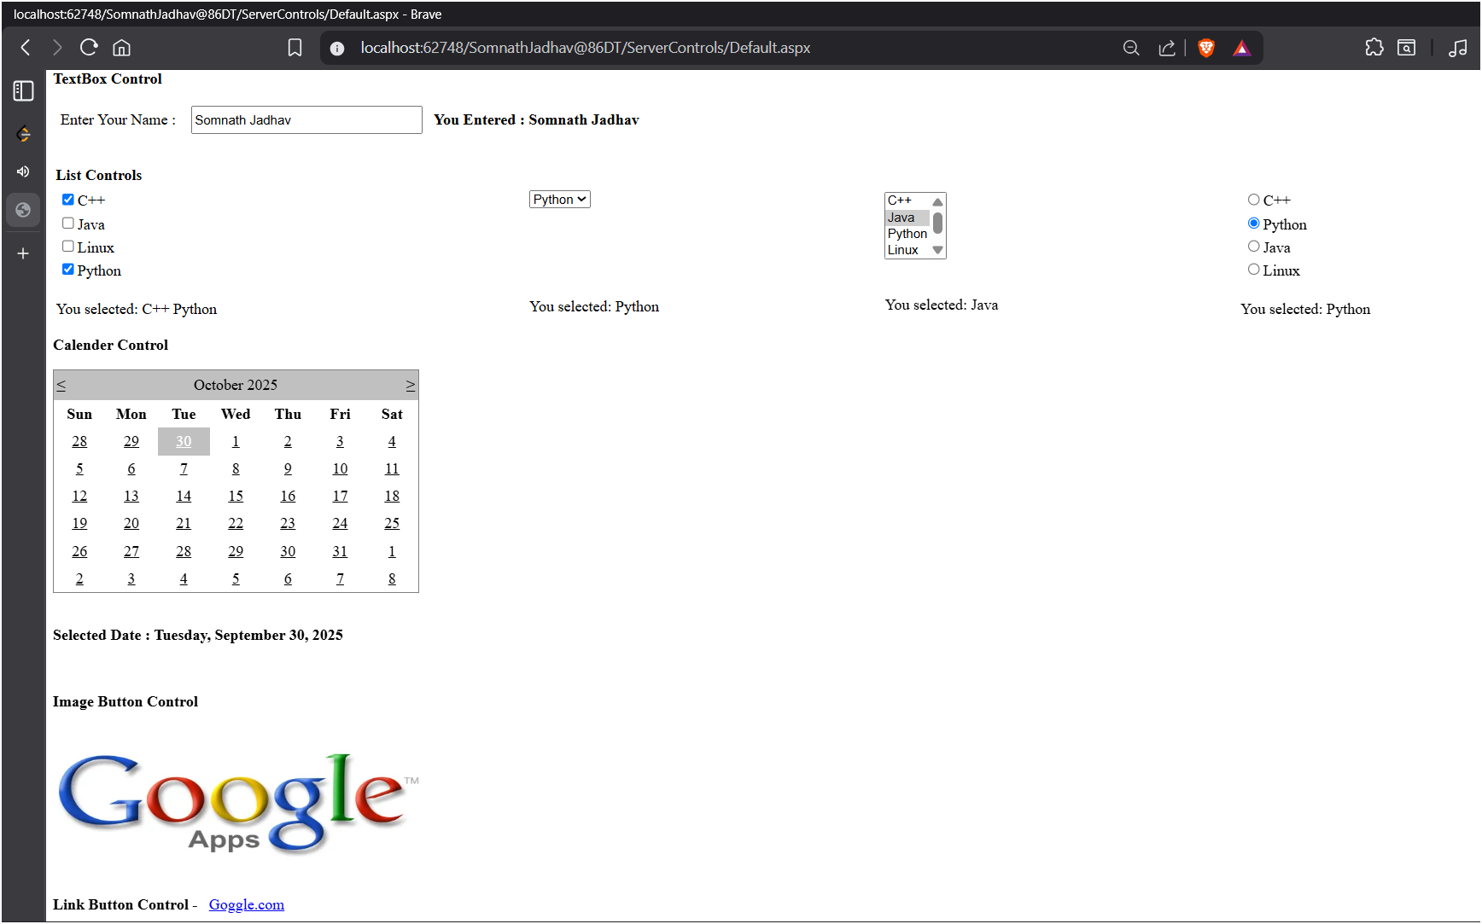

Name: Jadhav Somnath Pandurang

Class: BCA – III Sem – V

Roll No: 86

**LAB EXERCISE 6**

**Ques . Develop ASP.Net Application through which user upload Image and that Image should be displayed in Image Control.**

**Code:**

using System;

using System.Web;

using System.Web.UI;

using System.Web.UI.WebControls;

public partial class ImageUpload_Default : System.Web.UI.Page

{

protected void Page_Load(object sender, EventArgs e)

{

}

protected void Button2_Click(object sender, EventArgs e)

{

if (FileUpload.HasFile)

{

string fp = FileUpload.FileName;

string ext = System.IO.Path.GetExtension(fp).ToLower();

if (ext == ".bmp" || ext == ".jpg" || ext == ".gif" || ext == ".png")

{

FileUpload.SaveAs(Server.MapPath("uploads//") + fp);

Image1.ImageUrl += "~/ImageUpload/uploads/" + fp;

Label1.Text = "Image uploded Successfully ";

}

else

{

Label1.Text = "Invalid File.";

}

}

Console.Read();

}

}

**Output:**

**Before Upload -**

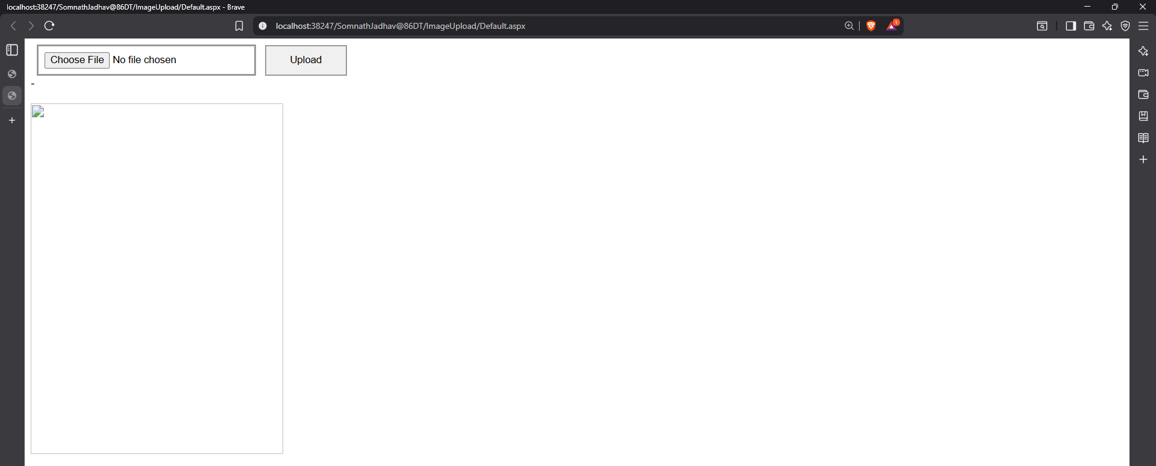

**After Upload -**

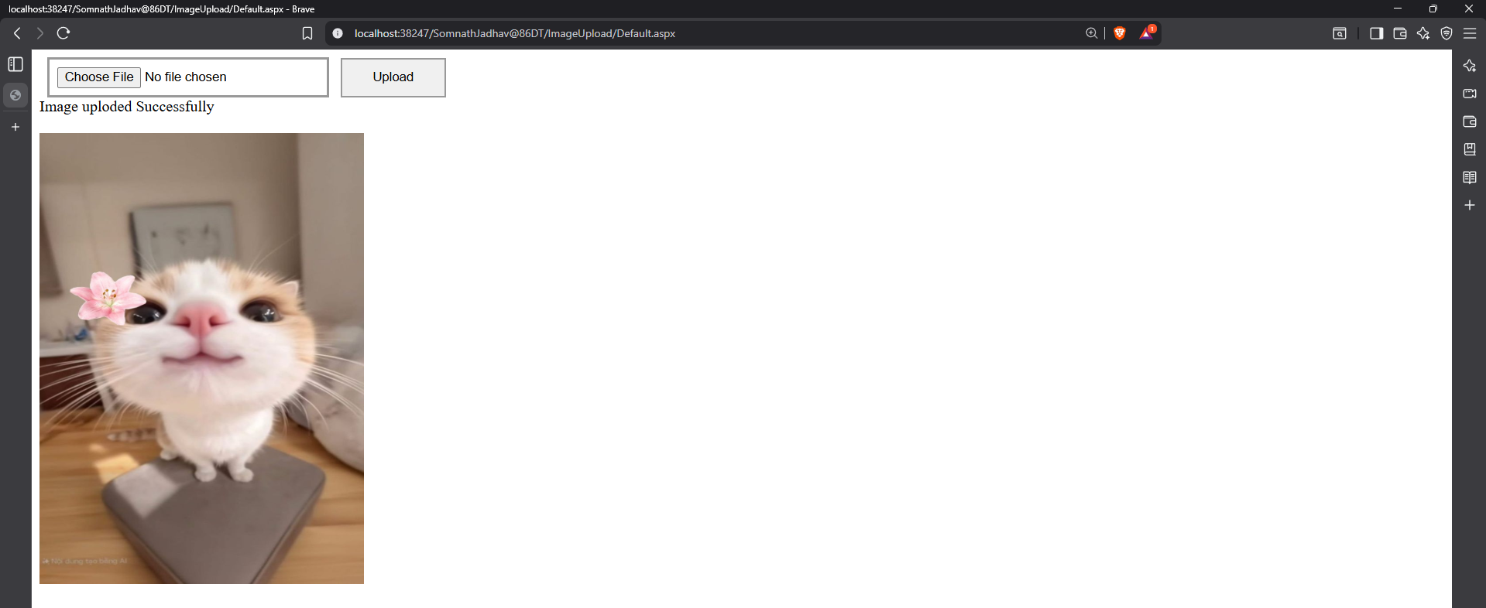

Name: Jadhav Somnath Pandurang

Class: BCA – III Sem – V

Roll No: 86

**LAB EXERCISE 7**

**Ques. Write a program to create a web page showing use of following validation controls - Required field validator, Range validator , Compare validator , Custom validator , Regular expression validator ,Validation summary**

RequiredFieldValidator -

* Ensures the user does not leave the field empty.
* Makes a field mandatory.
* Main Properties: ControlToValidate, ErrorMessage

RangeValidator -

* Validates whether the input falls between a specified range.
* Used for checking age, marks, amount, etc.
* Main Properties: MinimumValue, MaximumValue, Type

CompareValidator -

* Compares the value of one control with another or a fixed value.
* Commonly used for confirming password or matching entries.
* Main Properties: ControlToValidate, ControlToCompare, Operator

CustomValidator -

* Allows writing custom server-side or client-side validation logic.
* Used when built-in validators are not sufficient.
* Main Properties: OnServerValidate, ClientValidationFunction

RegularExpressionValidator -

* Validates input based on a defined pattern using regex.
* Ideal for email, phone number, and PIN code validation.
* Main Property: ValidationExpression

ValidationSummary -

* Displays all validation error messages together in one place.
* Improves UI by summarizing errors in a popup or panel.
* Main Properties: ShowSummary, ShowMessageBox, DisplayMode

**Output:**

**With Invalid Information –**

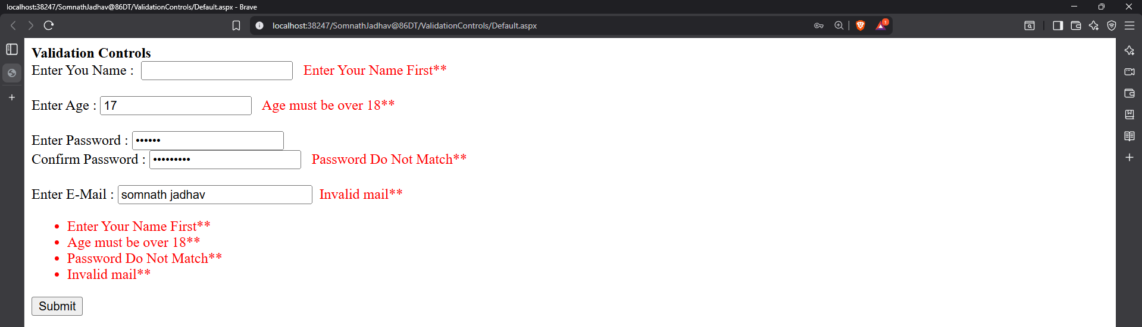

**With Valid Information –**

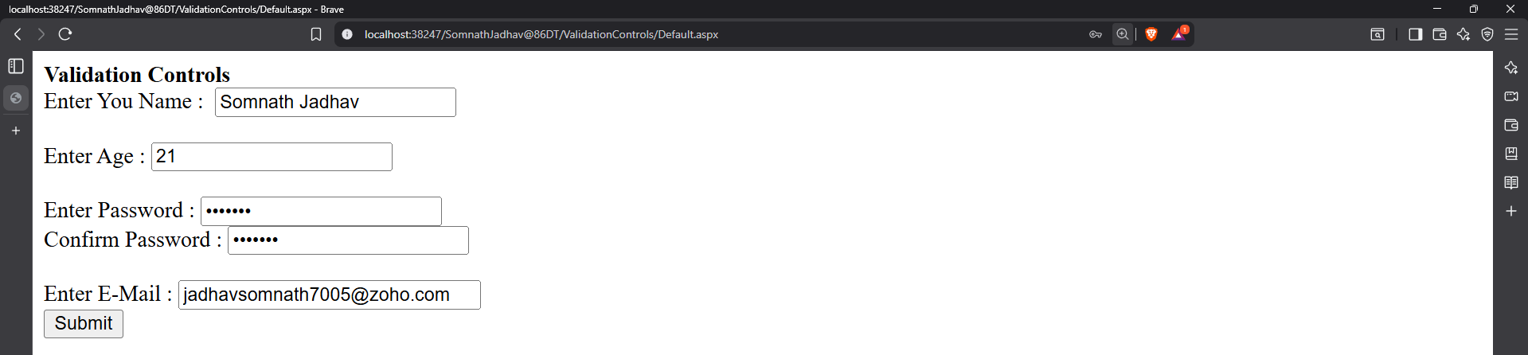

Name: Jadhav Somnath Pandurang

Class: BCA – III Sem – V

Roll No: 86

**LAB EXERCISE 8**

**Ques . Write a program to create a web page passing multiple values between asp.net pages**

**Code:**

**Form.aspx –**

using System;

using System.Collections.Generic;

using System.Linq;

using System.Web;

using System.Web.UI;

using System.Web.UI.WebControls;

public partial class _Default : System.Web.UI.Page

{

protected void Page_Load(object sender, EventArgs e)

{

}

protected void Button2_Click(object sender, EventArgs e)

{

Session["Name"] = TextBox1.Text;

Session["Age"] = TextBox2.Text;

Session["City"] = TextBox3.Text;

Response.Redirect("UserInfo.aspx");

}

}

**UserInfo.aspx –**

using System;

using System.Collections.Generic;

using System.Linq;

using System.Web;

using System.Web.UI;

using System.Web.UI.WebControls;

public partial class Default2 : System.Web.UI.Page

{

protected void Page_Load(object sender, EventArgs e)

{

string name = Session["Name"].ToString() ;

string age = Session["Age"].ToString();

string city = Session["City"].ToString();

Label1.Text = "Name: " + name + "<br/>" +

"Age: " + age + "<br/>" +

"City: " + city;

}

}

**Output:**

**Page 1 – Form.aspx –**

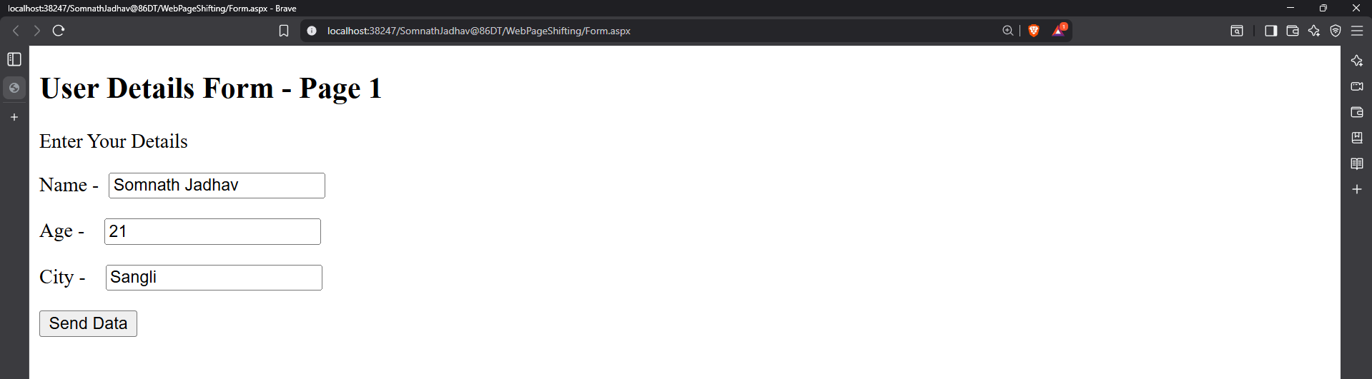

**Page 2 – UserInfo.aspx –**

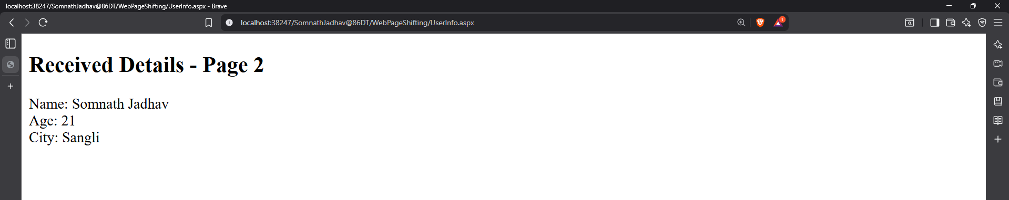

Name: Jadhav Somnath Pandurang

Class: BCA – III Sem – V

Roll No: 86

**LAB EXERCISE 9**

**Ques. Write a program to create a web page showing use of response, redirect and server transfer**

**Code:**

**Page1.aspx –**

using System;

using System.Collections.Generic;

using System.Linq;

using System.Web;

using System.Web.UI;

using System.Web.UI.WebControls;

public partial class _Default : System.Web.UI.Page

{

protected void Page_Load(object sender, EventArgs e)

{

}

protected void Button1_Click(object sender, EventArgs e)

{

Response.Redirect("Page2.aspx");

}

protected void Button2_Click(object sender, EventArgs e)

{

Server.Transfer("Page3.aspx");

}

}

**Page2.aspx –**

using System;

using System.Collections.Generic;

using System.Linq;

using System.Web;

using System.Web.UI;

using System.Web.UI.WebControls;

public partial class Page2 : System.Web.UI.Page

{

protected void Page_Load(object sender, EventArgs e)

{

}

protected void Button1_Click(object sender, EventArgs e)

{

Server.Transfer("Page1.aspx");

}

protected void Button1_Click1(object sender, EventArgs e)

{

Server.Transfer("Page1.aspx");

}

}

**Page3.aspx –**

using System;

using System.Collections.Generic;

using System.Linq;

using System.Web;

using System.Web.UI;

using System.Web.UI.WebControls;

public partial class Page3 : System.Web.UI.Page

{

protected void Page_Load(object sender, EventArgs e)

{

}

protected void Button1_Click(object sender, EventArgs e)

{

Server.Transfer("Page1.aspx");

}

}

**Output:**

**Page1.aspx –**

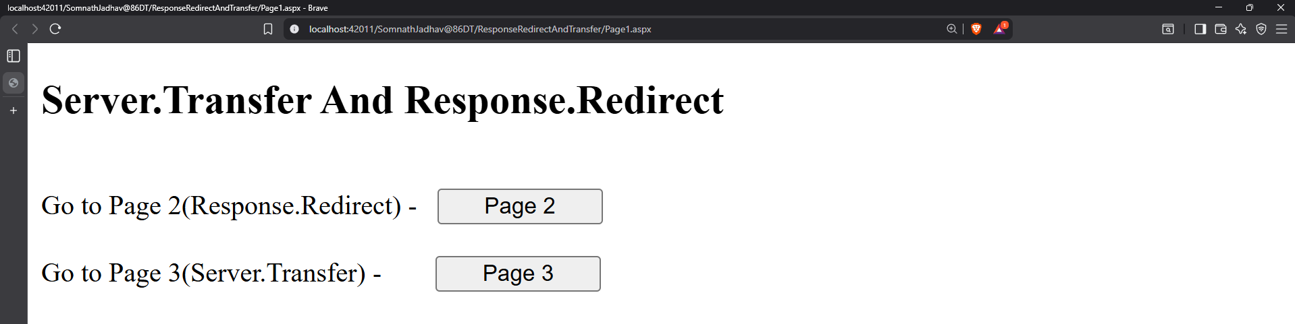

**Page2.aspx –**

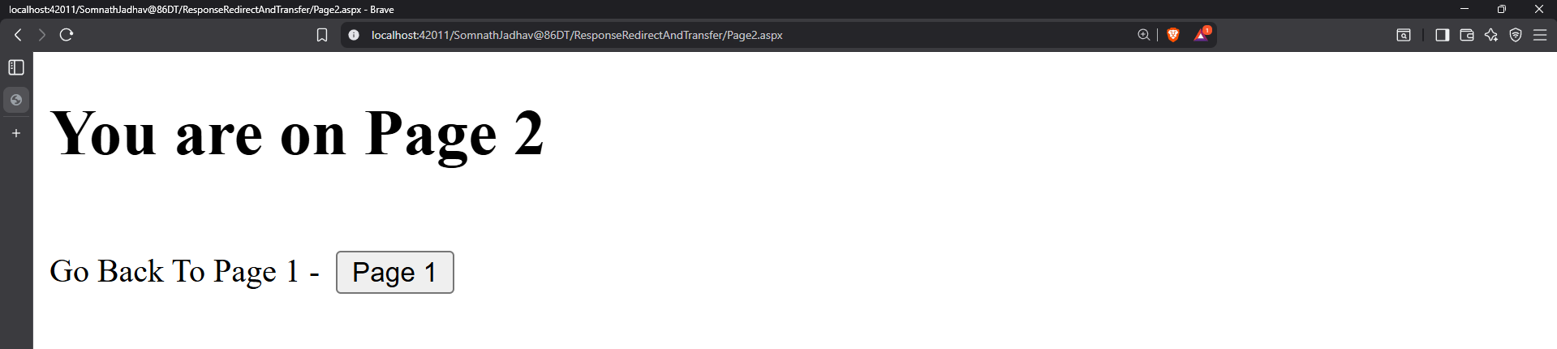

**Page3.aspx –**

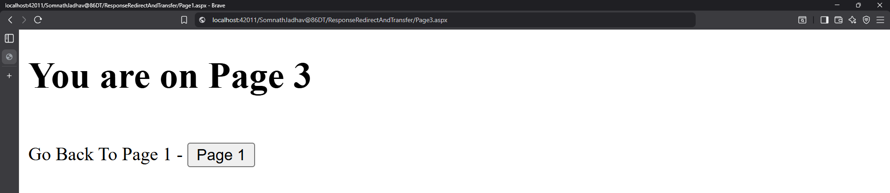

Name: Jadhav Somnath Pandurang

Class: BCA – III Sem – V

Roll No: 86

**LAB EXERCISE 10**

**Ques. Write a program to display student records form database using Grid view**

**Code:**

using System;

using System.Collections.Generic;

using System.Linq;

using System.Web;

using System.Web.UI;

using System.Web.UI.WebControls;

using System.Data;

using System.Data.SqlClient;

public partial class StudentForm_Default : System.Web.UI.Page

{

protected void Page_Load(object sender, EventArgs e)

{

}

protected void Button1_Click(object sender, EventArgs e)

{

SqlConnection conn = new SqlConnection(@"Data Source=(LocalDB)\v11.0;AttachDbFilename=D:\SomnathJadhav@86DT\App_Data\Database.mdf;Integrated Security=True");

SqlCommand cmd = new SqlCommand("SELECT * FROM STUDENTS WHERE Name = @name", conn);

cmd.Parameters.AddWithValue("@name", TextBox1.Text.Trim());

conn.Open();

SqlDataReader res = cmd.ExecuteReader();

if (res.HasRows)

{

while (res.Read())

{

Label10.Text = res["Id"].ToString();

Label11.Text = res["Name"].ToString();

Label12.Text = res["Class"].ToString();

Label13.Text = res["RollNo "].ToString();

Label14.Text = res["DOB"].ToString();

Label15.Text = res["PhoneNo"].ToString();

Label16.Text = res["Email"].ToString();

Label17.Text = "Record Found!";

}

}

else

{

Label10.Text = "NULL";

Label11.Text = "NULL";

Label12.Text = "NULL";

Label13.Text = "NULL";

Label14.Text = "NULL";

Label15.Text = "NULL";

Label16.Text = "NULL";

Label17.Text = "Record Not Found!";

}

conn.Close();

}

}

**Output:**

Before Searching

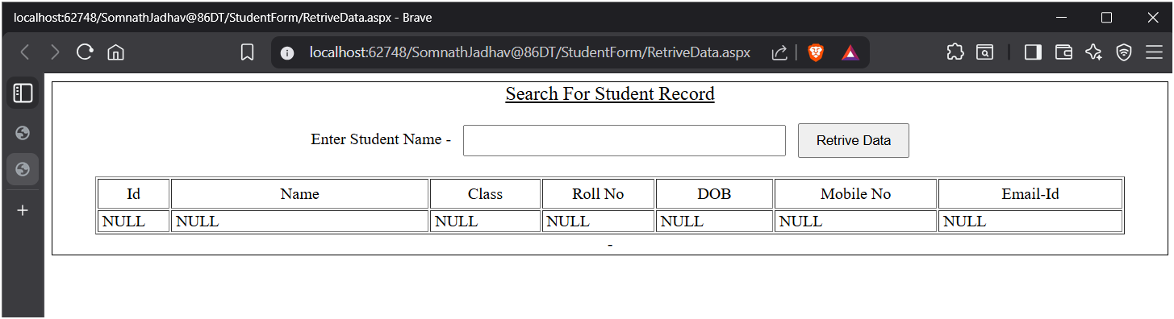

After Searching

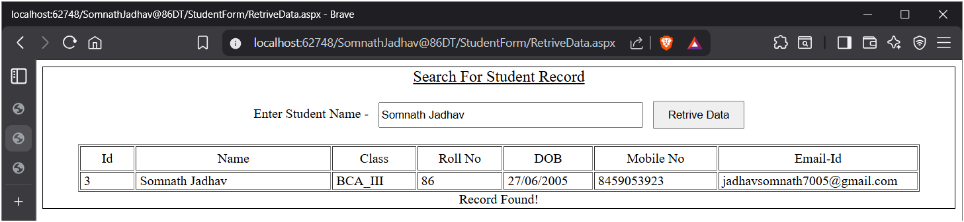

Name: Jadhav Somnath Pandurang

Class: BCA – III Sem – V

Roll No: 86

**LAB EXERCISE 11**

**Ques. Using ADO.NET, create a student database and perform operations like- insert, update and delete records.**

**Code:**

INSERT:

using System;

using System.Collections.Generic;

using System.Linq;

using System.Web;

using System.Web.UI;

using System.Web.UI.WebControls;

using System.Data;

using System.Data.SqlClient;

public partial class StudentForm_StudentForm : System.Web.UI.Page

{

protected void Page_Load(object sender, EventArgs e)

{

}

protected void Button1_Click(object sender, EventArgs e)

{

SqlConnection conn = new SqlConnection(@"Data Source=(LocalDB)\v11.0;AttachDbFilename=D:\SomnathJadhav@86DT\App_Data\Database.mdf;Integrated Security=True");

SqlCommand cmd = new SqlCommand("INSERT INTO STUDENTS(Name, Class, RollNo, DOB, PhoneNo, Email) VALUES (@name, @class, @rollno, @DOB, @phone, @email)", conn);

cmd.Parameters.AddWithValue("@name", TextBox1.Text);

cmd.Parameters.AddWithValue("@class", TextBox7.Text);

cmd.Parameters.AddWithValue("@rollno", TextBox8.Text);

cmd.Parameters.AddWithValue("@DOB", TextBox9.Text);

cmd.Parameters.AddWithValue("@phone", TextBox10.Text);

cmd.Parameters.AddWithValue("@email", TextBox11.Text);

conn.Open();

int res = cmd.ExecuteNonQuery();

conn.Close();

if (res == 1)

{

Label8.Text = "Record Saved Successfully";

}

else

{

Label8.Text = "Error while inserting!";

}

}

}

Insert Without Input:

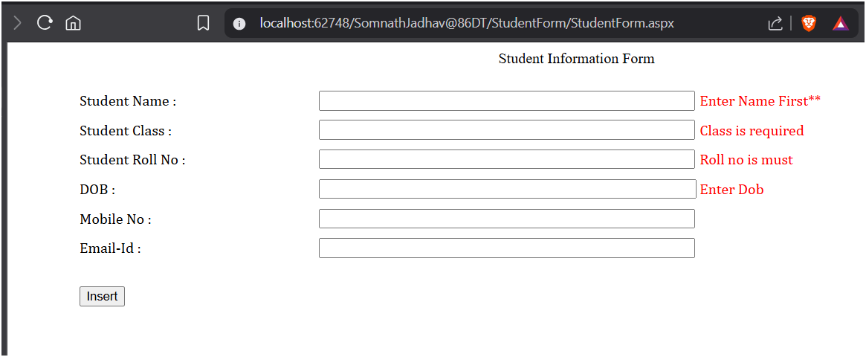

Insert Data:

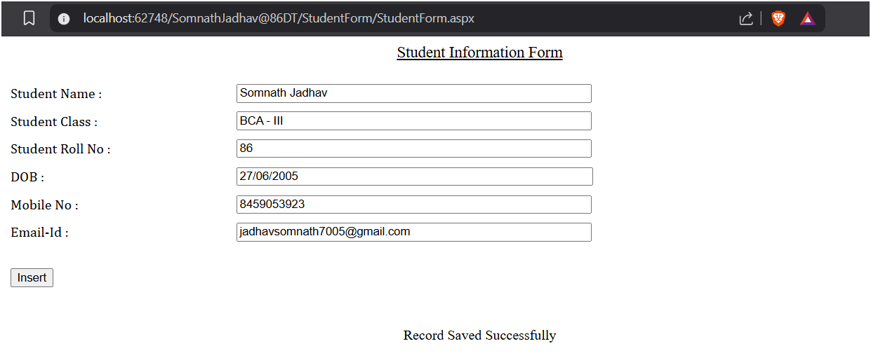

UPDATE:

using System;

using System.Collections.Generic;

using System.Linq;

using System.Web;

using System.Web.UI;

using System.Web.UI.WebControls;

using System.Data;

using System.Data.SqlClient;

public partial class StudentForm_DeleteRecord : System.Web.UI.Page

{

protected void Page_Load(object sender, EventArgs e)

{

}

protected void Button2_Click(object sender, EventArgs e)

{

SqlConnection conn = new SqlConnection(@"Data Source=(LocalDB)\v11.0;AttachDbFilename=D:\SomnathJadhav@86DT\App_Data\Database.mdf;Integrated Security=True");

SqlCommand cmd = new SqlCommand("UPDATE STUDENTS SET Class = @class, RollNo = @rollno, DOB = @DOB, PhoneNo = @phone, Email = @email WHERE Name = @name", conn);

cmd.Parameters.AddWithValue("@name", TextBox12.Text);

cmd.Parameters.AddWithValue("@class", TextBox7.Text);

cmd.Parameters.AddWithValue("@rollno", TextBox8.Text);

cmd.Parameters.AddWithValue("@DOB", TextBox9.Text);

cmd.Parameters.AddWithValue("@phone", TextBox10.Text);

cmd.Parameters.AddWithValue("@email", TextBox11.Text);

conn.Open();

int res = cmd.ExecuteNonQuery();

conn.Close();

if (res == 1)

{

TextBox12.Text = "";

TextBox7.Text = "";

TextBox8.Text = "";

TextBox9.Text = "";

TextBox10.Text = "";

TextBox11.Text = "";

Label11.Text = "Record Updated Successfully";

}

else

{

Label11.Text = "Error while Updating!";

}

}

protected void Button4_Click(object sender, EventArgs e)

{

SqlConnection conn = new SqlConnection(@"Data Source=(LocalDB)\v11.0;AttachDbFilename=D:\SomnathJadhav@86DT\App_Data\Database.mdf;Integrated Security=True");

SqlCommand cmd = new SqlCommand("SELECT * FROM STUDENTS WHERE Name = @name", conn);

cmd.Parameters.AddWithValue("@name", TextBox12.Text.Trim());

conn.Open();

SqlDataReader res = cmd.ExecuteReader();

if (res.Read())

{

TextBox12.Text = res["Name"].ToString();

TextBox12.Enabled = true;

TextBox7.Text = res["Class"].ToString();

TextBox7.Enabled = true;

TextBox8.Text = res["RollNo "].ToString();

TextBox8.Enabled = true;

TextBox9.Text = res["DOB"].ToString();

TextBox9.Enabled = true;

TextBox10.Text = res["PhoneNo"].ToString();

TextBox10.Enabled = true;

TextBox11.Text = res["Email"].ToString();

TextBox11.Enabled = true;

}

else

{

TextBox12.Text = "";

TextBox7.Text = "";

TextBox8.Text = "";

TextBox9.Text = "";

TextBox10.Text = "";

TextBox11.Text = "";

}

conn.Close();

}

}

Search and Update

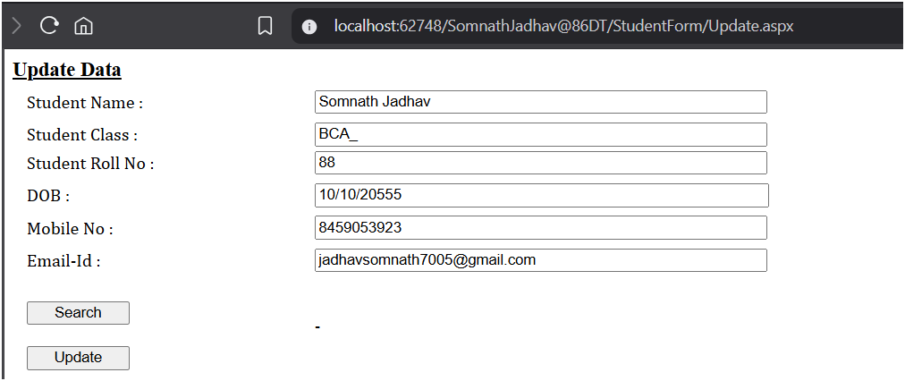

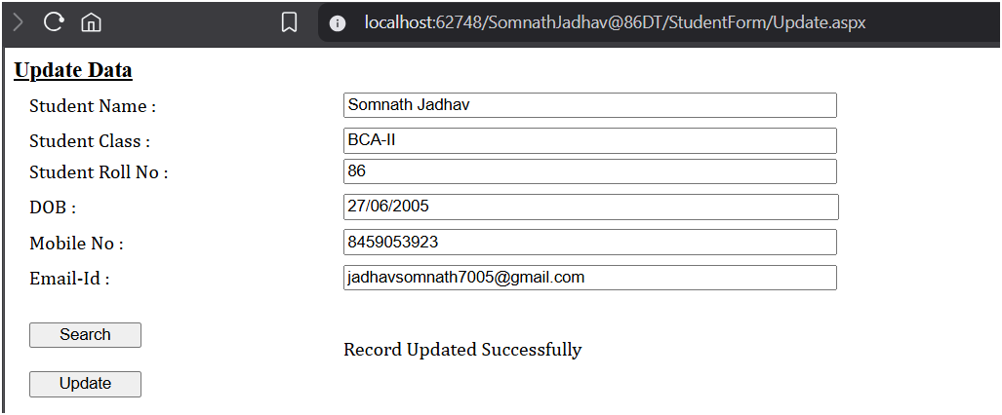

DELETE:

using System;

using System.Collections.Generic;

using System.Linq;

using System.Web;

using System.Web.UI;

using System.Web.UI.WebControls;

using System.Data;

using System.Data.SqlClient;

public partial class StudentForm_DeleteRecord : System.Web.UI.Page

{

protected void Page_Load(object sender, EventArgs e)

{

}

protected void Button1_Click(object sender, EventArgs e)

{

SqlConnection conn = new SqlConnection(@"Data Source=(LocalDB)\v11.0;AttachDbFilename=D:\SomnathJadhav@86DT\App_Data\Database.mdf;Integrated Security=True");

SqlCommand cmd = new SqlCommand("DELETE FROM STUDENTS WHERE Id = @id OR Name = @name", conn);

cmd.Parameters.AddWithValue("@id", TextBox1.Text);

cmd.Parameters.AddWithValue("@name", TextBox1.Text);

conn.Open();

int res = cmd.ExecuteNonQuery();

conn.Close();

if (res == 1)

{

Label3.Text = "Record Deleted Successfully";

}

else

{

Label3.Text = "Record Not Found!";

}

}

}



